ALAFREDY

Introducing AlaFredy

AlaFredy configures the AlaTimer users. With AlaFredy you are able to control and to monitor the use of the Computer and the Internet and to view the AlaTimer users’ Internet Activity.

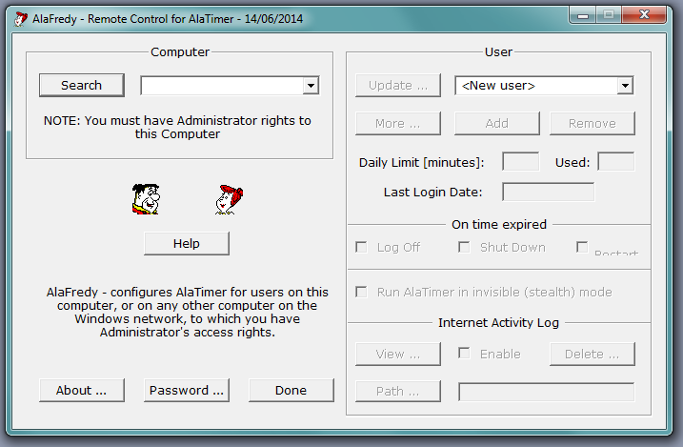

AlaFredy is installed with AlaTimer. It will not work if you are logged in as a Standard Windows User. In order to get access to use it you must have Windows Administrator’s rights. In addition, a password is required, in order to modify the users’ configuration, or to view their Internet activity logs.

With AlaFredy you can Add, Remove or Update the configuration of the AlaTimer users on the same (local) computer, or on any computer on your Windows network.

With AlaFredy you can also set AlaTimer to run in hidden (stealth) mode, you can view and manage the Internet activity log files and you can do so remotely too.

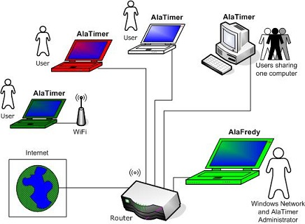

Using AlaFredy with AlaTimer on a Windows computer

To set an AlaTimer user on the (local) computer, select <New user> and type-in the user’s name, one that matches the user’s Windows log in.

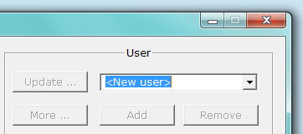

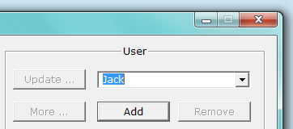

You may type-in an AlaTimer user name even if that user has not yet been set-up on Windows. However, the exact same user name must be later created in Windows, as a Windows user. In such case, you will see the following message:

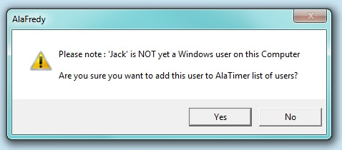

Having added the new user to the users’ list, you may now configure it for AlaTimer.

The user’s Daily (computer use) Limit, in minutes
[15 minutes to a maximum of 900 minutes]

What should happen « On time expired »
[Log Off, or Shut Down or Restart]

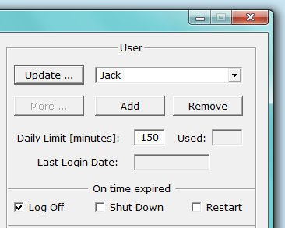

Enable the Internet Activity Log (if needed).

Select the Folder (Path) for the Internet Activity Log files, or use the default: « C:\_AlaTimer\<user name> »

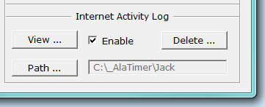

Click the « Update » button to save your configuration for this user and repeat the above, for additional users, as needed.

Changing AlaTimer users’ configuration

The AlaTimer users’ configuration may be altered at any time. You may modify the Daily Limit number of minutes, whether the computer should enforce a log-off, a shut-down or a restart.

Using AlaFredy to set-up AlaTimer users remotely

Click the Search button and wait for the list of computers to be displayed.

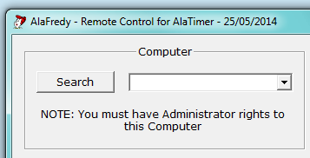

Select the computer, to which it is presumed that you have Administrator’s access.

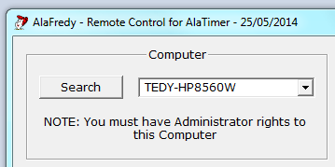

You will have to connect to this remote computer with the (Administrator) login user name and password as it has been defined for Windows on this remote computer.
You may now tick the « Stay connected » if you intend to set-up more users on this remote computer, otherwise you will have to repeat this login procedure, for every configuration change that you will attempt.

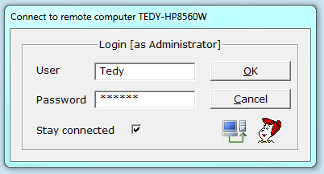

Select a user and proceed as described in the previous section.
If you have already configured AlaTimer users on the remote computer you will see the list of users, as below.

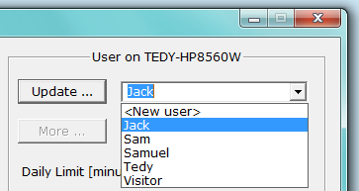

Modify AlaTimer user’s set-up on remote (networked) computers

Having connected to the remote computer, select a user from the list of users that is displayed and proceed with the configuration, as described above. If you have modified the configuration for an AlaTimer user that is logged in on the remote computer, your new configuration may take a few minutes to take effect. The remote user will be informed of the changes with a balloon type message.

Using Advanced settings [More button]

Click the « More » button and the following window will be displayed. Please note that by default, AlaTimer users have no schedule limit, neither for Computer use, nor for Internet browsing, therefore both « All Day » options are ticked.

Using this window you can set for each AlaTimer user a « From » - « To » schedule, in 15 minutes increments. Set the « From » hour and minutes to an earlier time than the « To » hours and minutes. If you have decided to set a schedule for the Internet browsing, ensure that this falls within the Computer use schedule, or else an error message will be displayed.

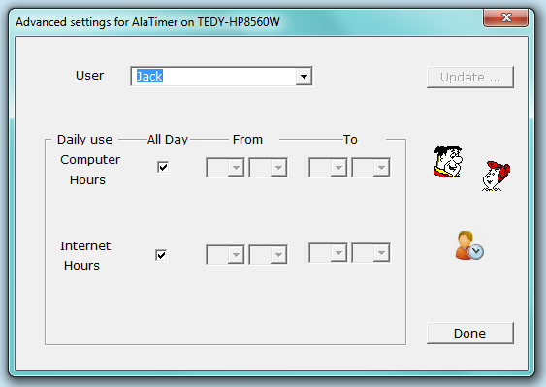

Click the « Update » button and you are done!

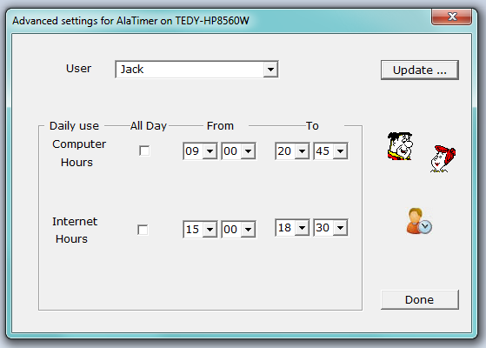

If you have made a change and have clicked the « Done » button, prior to clicking the Update button, a warning message will be displayed.
Confirming the update, the following message will be displayed:

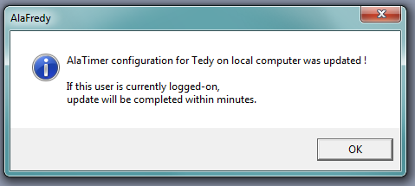

Much like all other configuration details, you may modify these schedules as or when you wish. The above message notifies you that if the schedules have been changed while the AlaTimer user is logged into Windows, either on a local or a remote computer, these changes might take a few minutes to take effect. If these changes were made for a user that is not logged in, the changes you have made will take effect as soon as that user will log into Windows.

Changing the password

The default password is « password » and you should change it as follows.
Click the Password button, type in the old password, the new password and confirm by re-typing the new password. Make sure that you safely record this password.

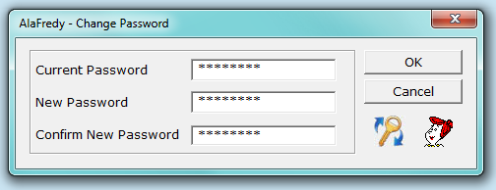

Running AlaTimer in hidden (stealth) mode

You may decide that for certain users AlaTimer should be invisible.
To hide the AlaTimer icon use the hot-key: ‘Ctrl-Alt-H’ (hold pressed the ‘Ctrl’ and the ‘Alt’ keys and press the ‘H’ key

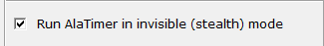

To go back to ‘visible mode’ use the hot-key: Ctrl-Alt-A.
Log and monitor users’ Internet activity

AlaTimer saves the Internet activity log in encrypted files in the folder that was selected with AlaFredy. Full access to this folder is allowed to Administrators only. The Internet activity date is stored in the files names, in the format yyyy-mm-dd. The file extension is .frd. These log files are decrypted and displayed with AlaFredy and access to them is secured with a password.

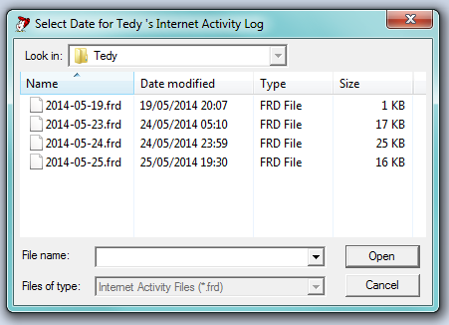

Viewing the users Internet activity [View button]

Click the « View » button and select the file (date) to display. A screen similar to that displayed below will be displayed.

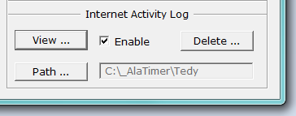

If you are seeing today’s Internet Activity file and the user is active browsing the Internet, clicking the « Refresh » button will update the screen with the latest (most current) web-sites visited.

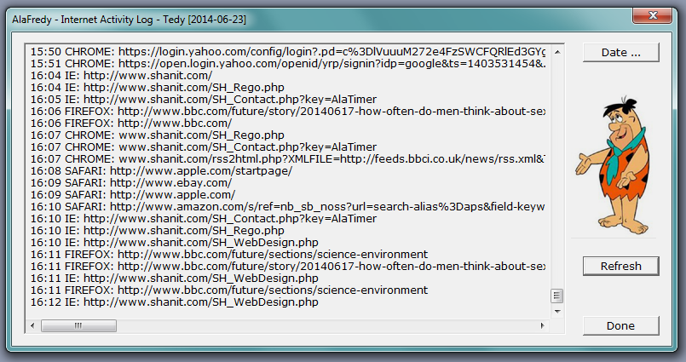

Clearing users’ Internet activity Log

With AlaFredy, you can manage the storage of the Internet activity log files. At any time you can decide to delete all files that are older than a certain number of days, or to delete all files for a certain user.

Click the « Delete » button.

The following will appear on the screen, providing a selection of 7, 15, 30, 60, 90, 120 or 365 days. You may also type-in any number of days, as needed.

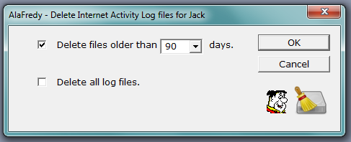

If confirmed but no log files older than the number of days selected are found, the following message is displayed:

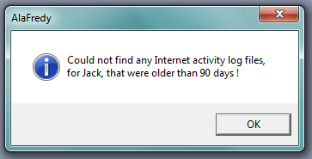

Otherwise you will see a message like the following:

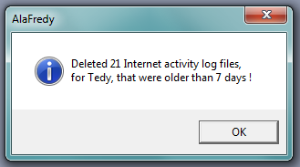

If you have selected to « Delete all log files », the following warning message will be displayed, asking you to confirm your request, before deleting all the Internet activity files for the selected user.

